Ladies Lake District 24 Hour Record

by Nicky Spinks

2nd / 3rd July 2011

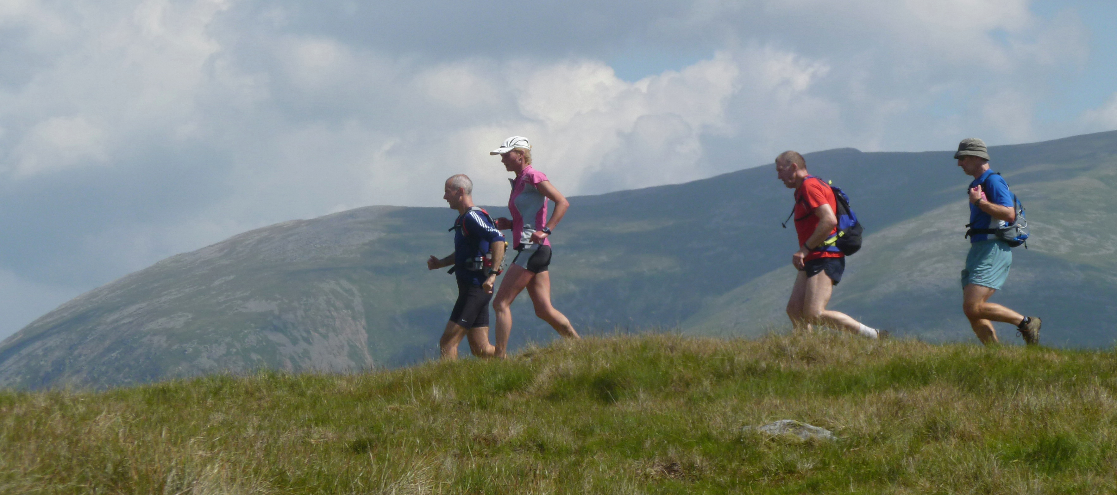

In 2005 I completed a BG with Dark Peak in 23.35 in murky conditions but I was always confident I could get round. In 2006 while researching into the Paddy Buckley I was given times for Mark Hartell, Anne Stentiford and Helene Diamenties. These I included in my spreadsheet of schedules and actuals that I was compiling but gave them a separate sheet named appropriately “Fast Times”. The times shown on the “Fast Times” sheet were incredible but I did notice and employ in my schedule the use of reducing stop times.

The work that I put into the Paddy Buckley I think has been the backbone of my subsequent successes. At the time there was no doubt in my mind that the Paddy was a lot faster than the BG and not only that but each leg has it’s own intricacies where to go the wrong way will cost you 15 minutes or more.

In May 2006 I attempted the Paddy. Looking back at the photos I needed my head testing. The weather was atrocious; thick clag and rain. Somehow I managed to stay just about on schedule until the last section which was from Capel Curig (as I had opted for a 6.30pm start from Aberglaysn). My stomach was shot and my legs soon followed. Supporters were walking next to me running. At the bottom of Cnict I should have been at the top to be in with a chance. 30 minutes to make up and only 1 hour left to do it in. It wasn’t going to happen. I walked off Cnict and all the way along the road to the finish. 25hrs 45 mins.

One month later I was diagnosed with Breast Cancer. Was it contributory? I don’t know. If I really believed it was I would have stopped running there and then. But I do know that I was in a worse state after my attempt than I have ever been in my life. I put my physical state down to the fact that I was very cold and very wet for a very long time. Mentally I was also very stressed out about my attempt.

The breast cancer care / treatment kicked in immediately. Two weeks later (3rd July) I was admitted for a mastectomy. Those two weeks were the longest of my life. I was convinced the cancer was spreading throughout my body. I had many sleepless nights checking my glands and body for other signs that I was going to die. The support I received from my family and the running community was incredible. I took solace from reading all my cards and looking at my flowers. Once the operation was over I felt a new person. I had hope. Another 3 weeks of waiting for the results was also mentally very hard. But then when the all clear came I couldn’t actually believe it. Over the next year I would now be undergoing breast reconstruction – expansion of my skin and subsequent operations in which implants would be inserted. I was back running within three weeks and I soon turned my attentions back to the Paddy.

I had learnt lots of lessons. Don’t set off in bad weather. Allocate more than one weekend for your attempt along with support. Buy some proper gear and put it on before you actually get cold.

Over the winter of 2006 I perfected the route and attempted in May 2007. Everything was going very well until Snowdon – only 5 hours into the round; I was 30 minutes up but suddenly I was sick. After that I struggled to eat however stayed up on schedule and even gained a little to Capel Curig. Then it all started to go pear shaped. Mark Harvey force fed me jelly babies and gels along the last section but I lost my advantage and my half hour spare in the schedule until on the top of Cnict I had an hour to get to Aberglasyn. Running my hardest along the road I was determined I wasn’t coming back again. I made it with 5 minutes to spare. 23 hrs 55 mins.

Another lesson learnt – even when you are sick you must continue to eat.

So a month past and I found myself in Scotland. It was mid July (midgy season); mine and Steve’s “holiday” walking and camping on the route of the Ramsay! Over the next summer / winter I reccied once a month through lots of snow and extreme weather. I attempted in May 2008 and was due to start at midday. I couldn’t sleep the night before and felt extremely sick. At 4am I had had enough “right let’s get this sorted”. Up I got and made myself some porridge. I got my book and slowly made myself eat the porridge. Back to bed – and to sleep!! When I woke my stomach was good. I ate more porridge and throughout the round I ate very well. I was sick only once and I was straight back to eating and good after that. I was so confident all the way round. I actually enjoyed it. I ran along the road to the YHA happy and strong in 22hrs and 30 minutes.

So I had completed all three of the rounds in under 24 hours – I was the 2nd woman to ever have achieved this. The 1st woman was Helene Diamenties.

The Lake District 24 hour round was suggested to me by Simon Rippon during the summer of 2010. I wasn’t sure I was fast enough so went up to the Lakes a few times and timed the splits against Anne Stentiford's (the current record holder) actuals. I was pleasantly surprised – they weren’t outrageously fast. I knew that to achieve this round I would have to get immersed in it, spending a lot of time going over the route and working on my “game plan”. It was a totally new experience for me; a) there was only one schedule to study whereas for other rounds I had many to choose from. b) it was my decision as to which extra hills to add in. c) after clarifying the rules it was also my decision as to where and when to start. I studied the Men’s round and followed their example planning to start at Stair and use dark time to run the road. Also any spare time at the end would also be “dark time”.

Over 2010 / 2011 I planned, reccied and trained. Using back to back races became the norm and a good method of teaching yourself discipline. I chose Fleetwith Pike and Sand Hill as my extras with Grisedale Pike a possibility if I was an hour up on schedule by Newlands Hause. I enlisted support from Dark Peak, Macclesfield and Penistone Footpath Runners. I asked Amanda Heading and my brother and wife (Charlie and Carol) to do my road support.

I chose the date of July 2nd/3rd with the 8th/9th as a backup. The weather looked fair for the first weekend and so the decision to go was made.

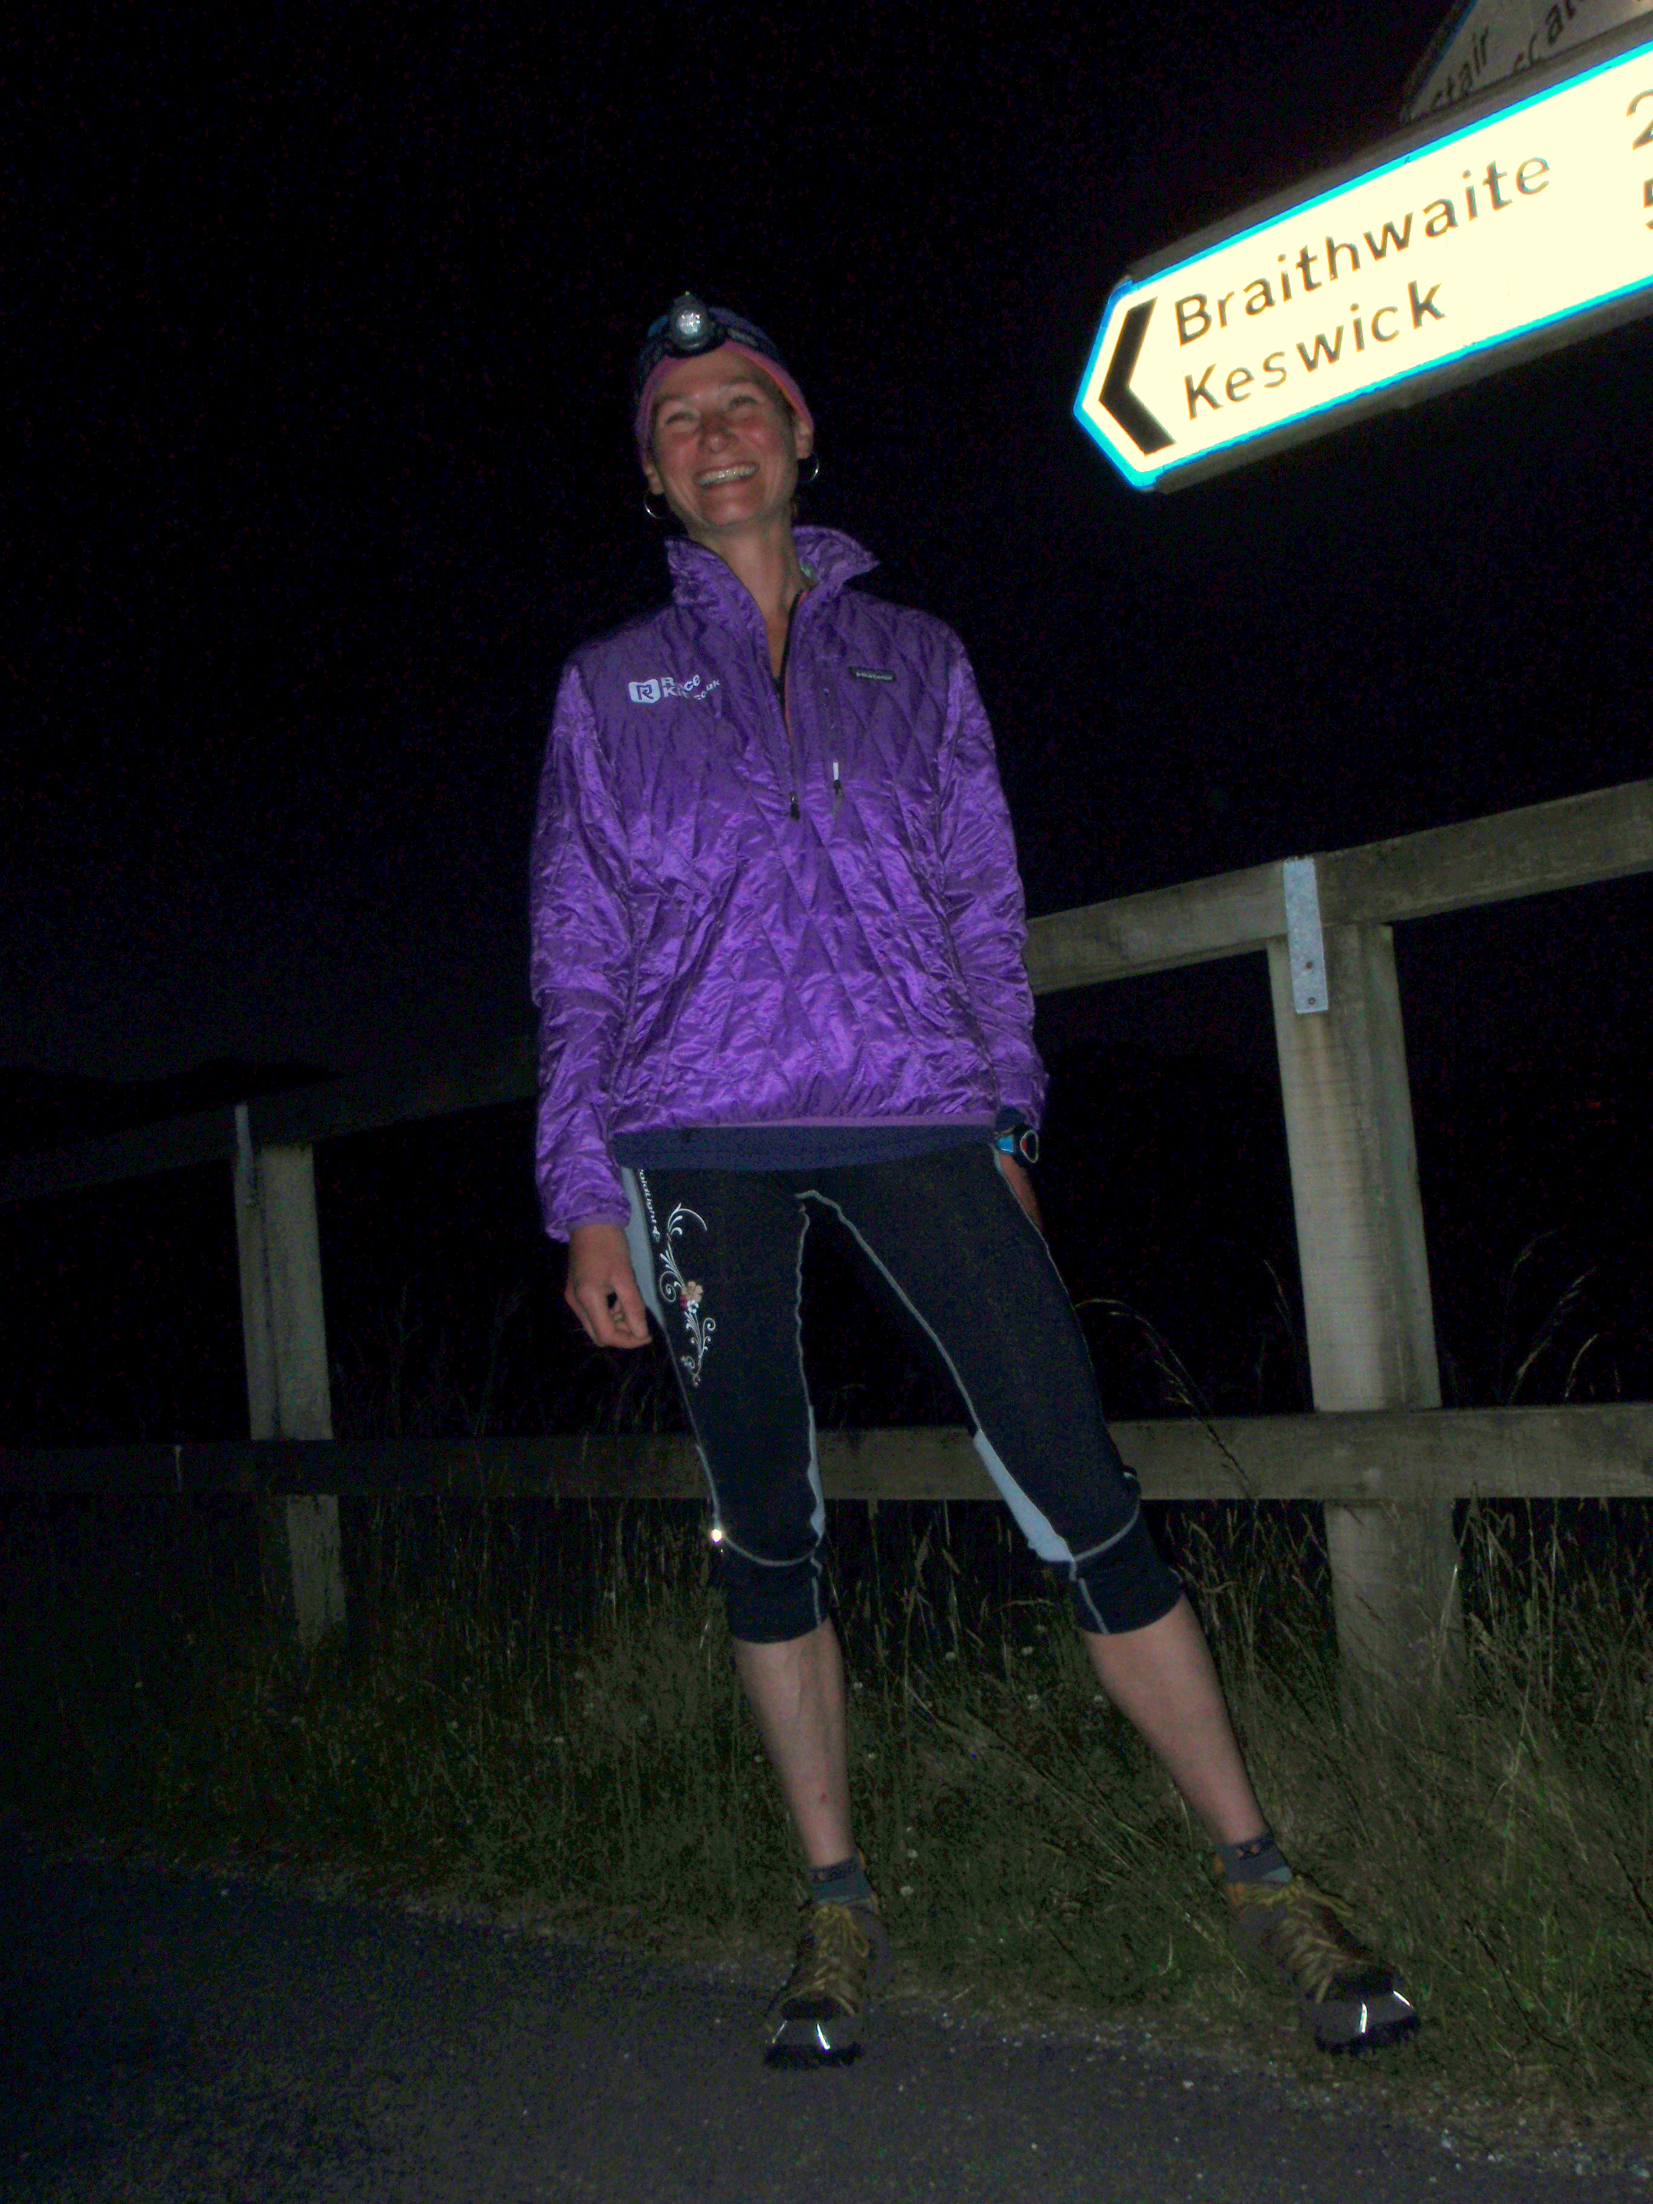
The fence at Stair road junction was my start. The day promised to be good - the sun was rising and there was only a little wind. At 3am we were off - my supporters were Neil Talbott, Simon Cox and Rick Houghton. I didn't know any of them very well but was struggling to find support for the 1st leg and so am very grateful to them for volunteering. I tried to settle into a steady pace while chatting. It was hard to make myself walk the hills but I knew I had to. I really liked bypassing Keswick by little back roads then a short distance of the A66. Climbing up onto the bridge we then walked / jogged all the way to Lonscale. It is always good to get a few peaks done, to realise the pace is possible and to settle down into the day. I knew we would gain time as Anne was running this leg in the dark. We were all enjoying the sunrise. The only worry I had was I could feel the back of my left knee niggling me. In fact I got so preoccupied by it that I turned my ankle - this got myself a telling off! Mungrisdale Comman felt easy; there was debate about the best line across to Blencathra so I took the middle. Approaching the summit I broke into a jog and met Yiannis who was to lead me down his "parachute drop" route. Following Yiannis made it very easy; I had reccied the descent many times but still wasn't confident to just keep running without checking the route. It was getting very hot; the long sleeved top came off. We flew down in about 17 minutes - and I'm not a fast descender!!

A quick stop for some beans and tea and I was off with Mike Robinson along the road. I don't mind Clough Head but it was getting too hot for me. Mike's racing line was very good and we were soon catching Martyn Goodwin and Tom Westgate. Neil had caught us up as he had decided to do more! I was wanting water but they had none so I drank some energy stuff instead. The ¾'s came off at the summit and I felt much happier running towards the Dodds. This leg went very well. I was aware that Anne had been feeling good on this leg and so I was worried about the split times but overall we were staying up on schedule. Catsycam I regarded as a very slow rocky ridge having only been along it in wind, rain or snow. I enjoyed the change of running to rock hopping and was really pleased to make another couple of minutes on the split. The walkers on route were very accommodating standing aside and even taking photos of me as I flew passed. On Helvellyn Kirsty and Julie were waiting with more rice pudding/fruit salad mix. Kirsty tucked in behind me as I ran passed. The split to Fairfield seemed fast so I pushed the pace trying to prove I could do it and I did. A horrid rocky descent to Seat Sandal and another leg nearly over. I knew the way off and resolutely followed my own line to bring me down the path.

At Dunmail I was in and out like a Formula 1 pitstop. Hat on, suncream applied, fuelled up, tea in and off. I was very impressed at the speed of these stops; thanks to Amanda Heading from www.racekit.co.uk for her brilliant organisation.

I set off up Steel Fell eating more beans "on the go" with Gavin Williams. Bob Berzins and Ian Charlesworth had set off already and we caught them at the top. A couple of minutes down but I was feeling the heat. Across to Calf Crag and then Raise. I was too hot and starting to feel sick. Still eating though as sometimes it can sort me out. But not this time - just off Raise and I was sick. Quick review of contents revealed the banana I had just eaten so that was pretty good. A packet of Hula Hoops by Sergeant Man had me back on track and I felt ok through the Langdales. Running off Harrison Stickle I heard someone call my name. It was Anne Johnson (nee Stentiford) shouting encouragement. That gave me a huge boost. We headed off to Rosset Pike still moving well although I was feeling a little rough and definitely too hot. Bernice Nixon and Yiannis met us by Angle Tarn and she had some Lucozade Sport. Sometimes something you don't expect does the trick. That went down very well and I tried some rice pudding going up to Bowfell. From now to the finish most of my thoughts were concentrated around what I could eat, how my energy levels were and whether I was going to be sick or not. I was sick again a few times on this leg but always had something else I could eat afterwards. I will never forget the walkers faces though on Ill Crag as I was projectile sick in front of them and Bob calmly handed me some water and ran off. Scafell Pike was crowded but Yiannis insisted on photos and I'm really grateful now that we stopped for precious moments to capture the moment. Broad Stand was busy; Bob tied me into the rope and I followed Yiannis up the rock. Gavin untied me and I set off. I had a vague recollection that I should cross the gully but followed Yiannis up. Gavin shouted but it was too late; next time I will get it right! I glanced right as we emerged at the top across to the top of West Wall Traverse; not something I was looking forward to. However with Gavin leading and Yiannis keeping a respectable distance behind I quite enjoyed the headlong descent. The contour path to Lingmell is a joy and nearing the end of another leg I was in good spirits. We regrouped on the descent to Wasdale and I ran down trying to ignore the looming presence of Yewbarrow across the valley.

I was processed through the pit stop again. My brother Charlie on map duty - old map out, new map in. The photos show me smiling but I remember telling Amanda that "it was hard". As usual she was her professional self "what did you expect?"! Exactly. I had some pasta and walked off determined it was not going to make a reappearance.

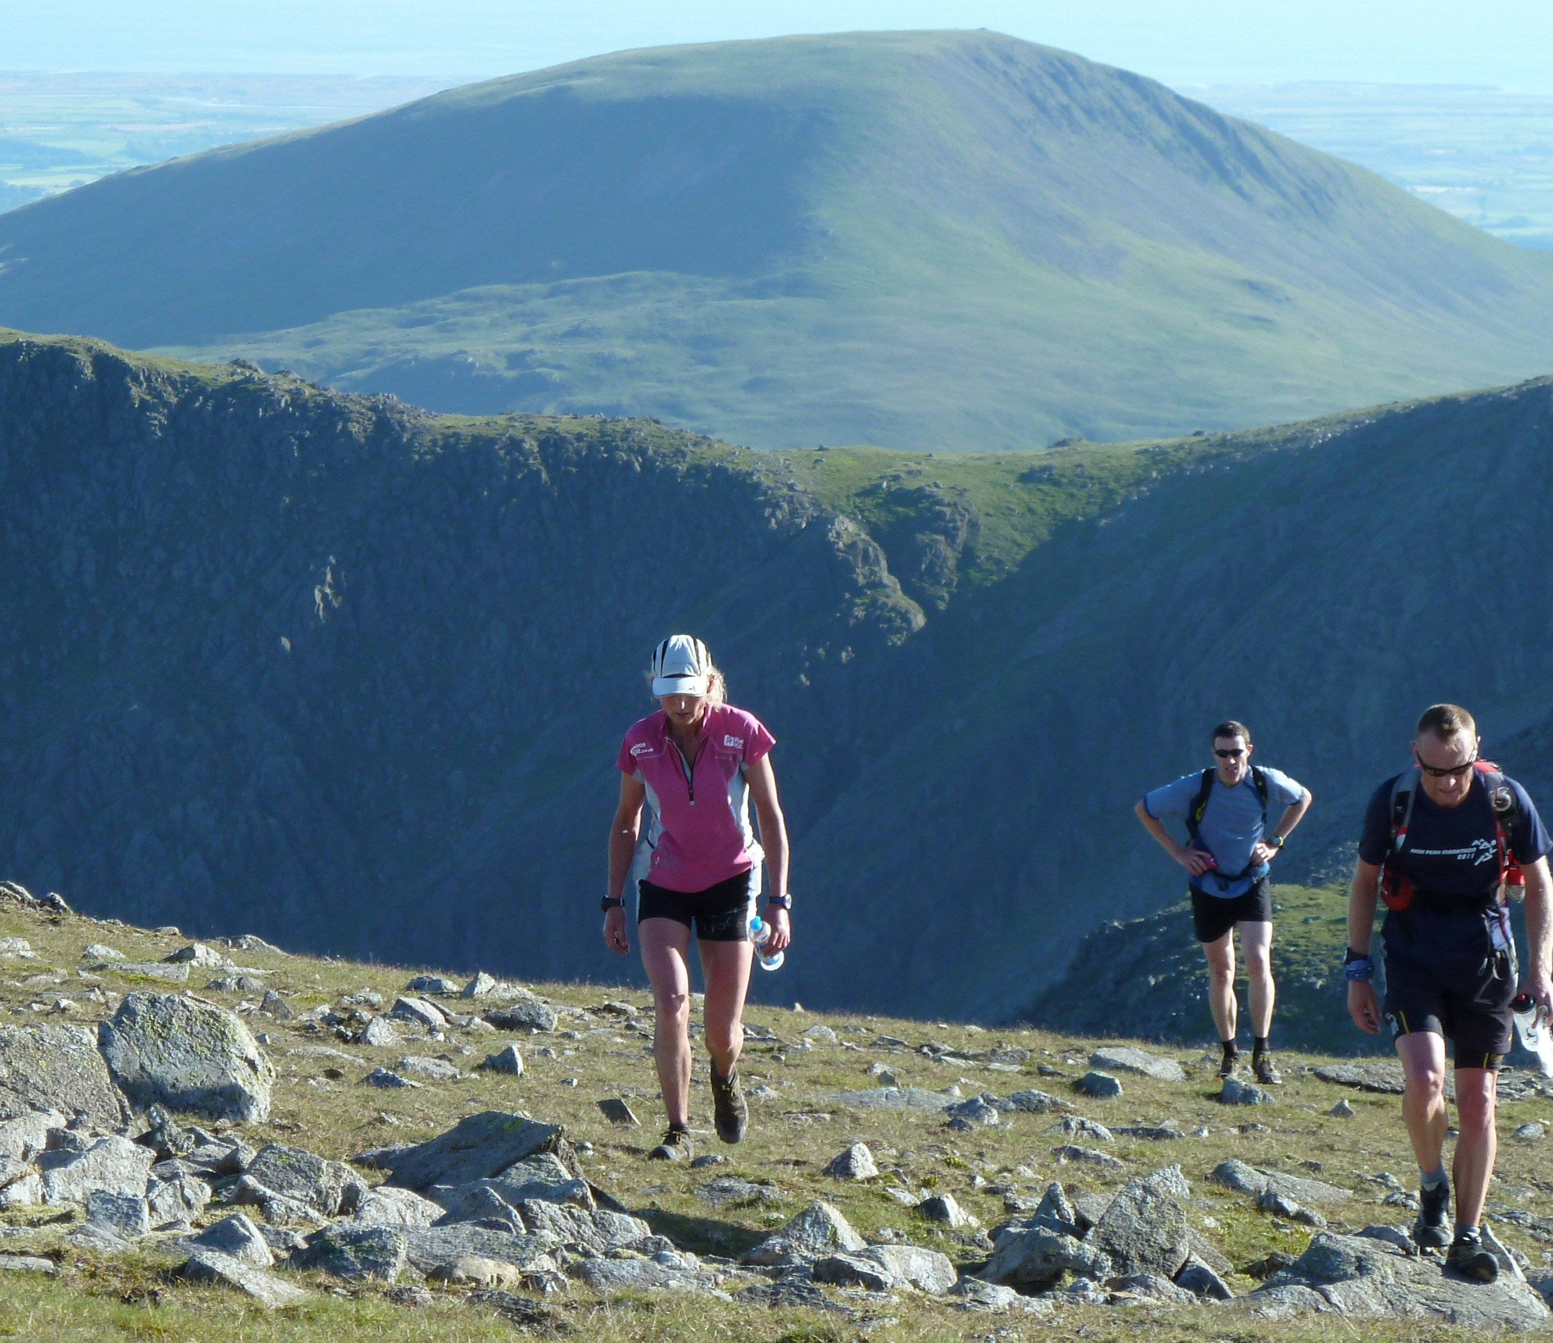
Off up Yewbarrow with Chris Chripps, Simon Rippon and Dave Sykes. It wasn't too hot and my stomach felt ok. I didn't think we were on the pace and so was very pleased to reach the top only a few minutes down (a pattern was emerging although at the time I didn't realise it). Over to Stirrup Crag and off upto Red Pike. Here the wind dropped and it felt like a furnace. I was timing the splits and thought we were way off the pace. However by mistake I hadn't timed Stirrup Crag therefore we were actually up when I thought we were down. My stomach was not good. I was running out of food to eat that I hadn't been sick on but ate hula hoops (well one off every summit to be exact - not exactly energy creating) and pizza. I remembered Mike Hayes notes from my BG - "3 big pigs" he calls Pillar, Kirkfell and Gable. By Kirkfell I was feeling good and made up some more time there. Barbara and Ian Fitz had walked up with coffee and coke before Great Gable - that made a nice change. Off down to Green Gable and onwards to Grey Knotts. I was feeling rough but looking across to Fleetwith thinking its mine - an extra. Chris took me on a line I didn't know but was better than mine and even with a sick stop we made good time. Being sick was getting on my nerves now. More and more food options were being thrown up. I discussed with Ian the use of gels. I decided that with about 5 hours to go I could probably survive on them. I have previously.

At Honister I was an hour up on schedule - this was my goal. I got processed through pit stop this time with soup, tea and clean tops. I set off up Dale Head with Willy Kitchen, Brent Lindsey, Roy Gibson and Julie Gardner. This leg went ok until the top of Robinson. Although I wasn't eating much the gels were going down and staying down. It was dark on Robinson and to me there seemed to be people and lights everywhere. I got very disheartened at the thought of Whiteless Pike ahead and then when the supporters didn't follow my line but their own I almost fell apart. Walking through the marsh I was at my lowest. On one descent we had lost the advantage I had gained and were less than an hour up on schedule making it impossible to include Grisedale Pike. Running into Newlands I knew I needed a boost. I had some beans and changed my leggings. I saw my dad looking worried and wanted to say "I'm ok" But no time; with a hug from my brother and some strong words from Amanda I was off on the last leg.

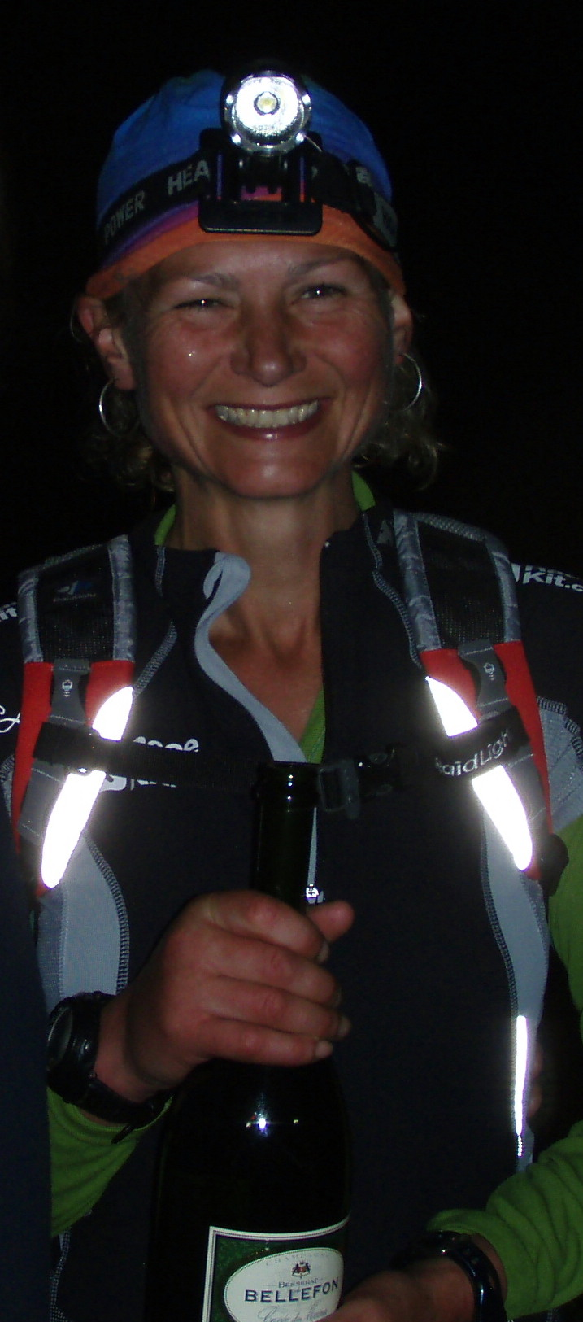
Once again I felt sick on the climb and it was an effort to keep food down and keep going. The bracken had grown two feet in two weeks and we battled our way through it with Mark Townsend, Helen Elmore, Nick Cable and Rick Houghton trying to blaze a trail. Once climbing I worked on sorting my head out. "You're OK. This is possible. 64 peaks is a good tally. It will just have to be Sand Hill. How many more hours? Can I manage on gels?" Halfway up Mark drops back to talk to me. Sand Hill I say. He agrees. Once the decision is made I settle into the climb and (once again) we only lose a couple of minutes. I feel happier; only slightly worried about Eel Crag but on the whole energy and legs are fine. I refuse all food but get lots of gels down along with water. We're making time up again and I start looking at my watch trying to work out whether to go for Grisedale. My fuddled brain says "It simply isn't worth it to get an extra one but be over 24 hours" - probably good advice. Mark's nav is perfect and we all walk / run together in companionable silence. Sand Hill - my second extra is another boost. All I've got to do now is get home. Eel Crag is fine and we see lights on Causey Pike from the top. Ian Winterburn being lookout; it's nice to have a final target to aim for. There is a strange light across to our right - noctilucent clouds apparently. It was pretty though and I would have liked time to stop. On Sail Pass I am met by Wendy Dodds and Yiannis; two inspirational "round" specialists. My legs are complaining but I glance at my watch to see how long we have. Maybe I can make 23.15 I think. I push on and on down the stony path. I can't see any lights or hear anything "maybe no-one is there?" As we round the corner though all the cheering starts, I grin and there is spring in my step as I spy the fence. Crossing the road, I reach out and touch it. Then hug it and all my supporters, friends and family.

Absolutely wonderful. I have done it. 64 Peaks in 23 hours and 15 minutes. Steve is grinning from ear to ear and opens some champagne, I take a sip mindful of the effect it will have on my stomach! I stand like a superstar while cameras flash. I was so pleased to have finished and that everybody was there to celebrate with me.

